**MSIS 670 Group - 6 Business Intelligence**



**MSIS 670 Business Intelligence**

**Final Project Report 2022**

**Ankita Kashyap**

**Priyal Ravat**

**Duc Tan Nguyen**

**Arushi Gupta**

**MSIS 670 Business Intelligence**

**Final Project Report 2022**

**Alcohol’s effect on Study**

**1. Data Set Description** …**…………………………………………………………………. 4**

1.1. What is your data set?

1.2. Why did you choose this data set?

1.3. Where did you get this data set (and other relevant info)?

1.4. What did you do for data “cleaning”?

**2. Data Visualization by Tableau……………………………………………………………. 6**

2.1. Deeds that have led to the student drinking alcohol in the first place?

2.2 Does alcohol affect study? / Does heavy drinking affect academic performance in college?

2.3 What accountability do parents and guardians have in this case?

**3. Conclusion** …**………………………………………………………………………………** **10**

3.1. Visual Summary and New Insights

3.2. What did you learn about data visualization concepts and lessons, especially to address the questions?

3.3. What did you learn about the data visualization software application - Tableau?

**4. Appendix …………………………………………………………………………………… 12**

4.1. Visualizations for the first question and their interpretations (findings)

4.2. Visualizations for the second question and their interpretations (findings)

4.3. Visualizations for the third question and their interpretations (findings)

**5. References ...………………………………………………………………………………… 20**

# 

# **1. Data Set Description**

**1.1. About our Dataset**

A data set is a structured group of data. As we are all aware, data is a grouping of information that has been gathered by observations, measurements, research, or analysis. Facts, figures, names, and even simple descriptions of items might be included in it. The organization of data might take the shape of graphs, charts, or tables. We used a data set for this investigation. It is based on research showing how alcohol affects learning. How alcohol consumption by underage pupils will influence them as well as the various factors that are contributing to the issue.

**1.2. Why did you select this data set?**

An alcoholic beverage is a beverage that includes ethanol, a kind of alcohol that acts as a narcotic and is produced by fermenting grains, fruits, or other sources of sugar. Alcohol is one of the most widely used recreational substances in the world, used by around 33% of the population. The drug that young people use the most commonly in the US is alcohol. Data from a number of national research indicate that youth consume alcohol. These issues are more likely to affect young people who binge drink than those who do not. Early alcohol usage can raise the chance of later having an alcoholism disorder. According to studies published in the journal Drinking, alcohol has both acute and long-term effects on the areas of the brain connected to learning. Even a few glasses of alcohol, according to the National Institute on Alcohol Abuse and Alcoholism, can impair memory, and the damage worsens as one consumes more alcohol. This is the reason why we choose this data set.

**1.3. Where did you obtain this data set?**

Kaggle was used to discover the data set. Data scientists and machine learning experts may connect online at Kaggle. Users of Kaggle may discover and share data sets, study and develop models in a web-based data science environment, collaborate with other data scientists and machine learning experts, and participate in contests to address data science issues. In addition to providing machine learning contests when it was originally created in 2010, Kaggle currently provides a public data platform, a cloud-based workbench for data science, and artificial intelligence training.

**1.4. What did you do to “clean” the data?**

Data cleaning is the process of removing erroneous, damaged, badly formatted, duplicate, or missing data from a dataset. When combining several data sources, there are many possibilities for data to be duplicated or improperly classified. Even though findings and algorithms seem to be correct, faulty data makes them untrustworthy. There is no definite method to define the specific steps in the data cleaning process because the techniques will vary from dataset to dataset. The following criteria, which are detailed below, were taken into consideration when cleaning the dataset.

* Do the data numbers make sense?
* Does the data follow the rules that are relevant to its specific field?
* Does it validate the working hypothesis or refute it? Does it provide any fresh details?
* Are there any trends in the data that can aid in the creation of the next theory?

# **2. Data Visualization by Tableau**

**2.1 Deeds that have led the student drinking alcohol in the first place**

To solve a problem, we need to know the root cause of the problem. In this part, we are trying to analyze the possible reasons to get into a drinking habit.

1. **What are the causes that students started drinking?**

There can be many possible reasons for an underage student to get involved in drinking habits. We are focusing on parameters like going out with friends (goout), number of past failure classes (failures), amount of free time they have after school (freetime).

Value Range:

Goout field is measured on a scale of 1 to 5. Numeric value 1 being very low chances of going out and 5 being very high,

Failures counts the total number of students that failed,

Freetime is measured on a scale of 1 to 5. Numeric value 1 means very low leisure time and 5 being very high.

1. **How will it affect their presence in school?**

There are many factors including daily drinking habits, environment (i.e their living location and school) that can affect a student’s presence in school.

To demonstrate this, we have used data like DALC(workday alcohol consumption), WALC(weekday alcohol consumption), Address (student's home address type), School (student's school).

Value Range:

DALC: numeric: from 1 - very low to 5 - very high

WALC: numeric: from 1 - very low to 5 - very high

Address: binary: 'U' - urban or 'R' - rural

School: binary: 'GP' - Gabriel Pereira or 'MS' - Mousinho da Silveira.

1. **How can family relationships influence the student’s drinking habit?**

Family being a fundamental unit in a person’s life makes a major impact on a person’s life. Relationships between family members can make or break a child’s mental health. This can also affect their social life and in turn influence their drinking habit. To show this, we have used data such as Pstatus (parent's cohabitation status) and Famrel (quality of family relationships).

Value Range:

Pstatus: binary: 'T' - living together or 'A' - apart

Famrel: numeric: from 1 - very bad to 5 - excellent**.**

**2.2 Does alcohol affect study? / Does heavy drinking affect academic performance in college?**

* 1. **How does it affect the student?**

Alcohol can have several negative effects on students. Some of the potential effects of alcohol on students include:

* + - Impaired cognitive function, making it more difficult to concentrate, remember information, and learn
    - Increased risk of injuries, such as falls and accidents
    - Increased risk of physical and sexual assault
    - Increased risk of alcohol poisoning, which can be life-threatening
    - Increased risk of long-term health problems, such as liver disease and certain types of cancer

In addition to these physical effects, alcohol can also have negative social and emotional consequences for students. Heavy drinking can lead to relationship problems, legal issues, and other negative outcomes. It can also interfere with a student's ability to perform well academically, which can have long-term consequences for their education and career prospects.

Overall, it is important for students to be aware of the potential negative effects of alcohol and to drink responsibly and in moderation.

* 1. **What will happen after a period of consumption?**

After a period of alcohol consumption, a student's blood alcohol content (BAC) will rise. As a student's BAC increases, they will begin to feel the effects of alcohol, which can include slurred speech, loss of coordination, and a decreased ability to think and react. In extreme cases, excessive alcohol consumption can lead to alcohol poisoning, which can be life-threatening.

In addition to these physical effects, alcohol consumption can also have negative social and emotional consequences for students. Heavy drinking can lead to relationship problems, legal issues, and other negative outcomes. It can also interfere with a student's ability to perform well academically, which can have long-term consequences for their education and career prospects. It is important for students to be aware of the potential negative effects of alcohol and to drink responsibly and in moderation. This can help them avoid the negative consequences of alcohol consumption and maintain their physical, social, and emotional well-being.

* 1. **What remedies should be done to deal with this effect?**

There are several steps that schools and parents can take to decrease underage alcohol consumption. Some strategies include:

* Educating young people about the risks and dangers of alcohol consumption, including the effects on their health and development, as well as the legal consequences of underage drinking.
* Establishing clear rules and expectations around alcohol consumption, and consistently enforcing them.
* Monitoring the activities of young people and intervening if they are at risk of drinking or have already consumed alcohol.
* Providing support and resources for young people who are struggling with alcohol use, such as counseling and treatment programs.
* Working with community organizations and law enforcement to reduce the availability of alcohol to underage youth.

By implementing these and other evidence-based strategies, schools and parents can help decrease underage alcohol consumption and promote healthy behaviors among young people.

**2.3 What accountability do parents and guardians have in this case?**

Young people who have supportive and involved parents are less likely to engage in risky behaviors, including alcohol use. This is because parents can provide guidance, support, and supervision that can help their children make healthy decisions and avoid risky behaviors. Additionally, parents can play a role in preventing underage drinking by setting clear rules and expectations around alcohol use, monitoring their child's activities, and providing support and resources if needed. By being involved and supportive, parents can help their children make healthy choices and reduce their risk of engaging in alcohol-related behaviors.

However, it is important to note that other factors, such as a student's peer group and the community in which they live, can also affect their alcohol consumption. As a result, it is not possible to definitively say that the type a student's guardian will affect their alcohol consumption.

1. **Who is the students’ guardian?**

For a student’s guardian, caregivers are likely to influence school-related decisions and actions for a student's guardian. They could be parents, fathers, mothers, or others.

1. **How parents’ education level affect child's education?**

According to reality, parents with a higher level of education have more confidence in their child's academic abilities and they have higher expectations of their child.

They anticipate that their child will excel academically, behave well in school, and attend college. These lofty objectives inspire their child to succeed. Their belief in their child encourages their child to believe in their academic abilities, increasing their chances of success.

From the collected data, we analyze parents’ education as their current jobs:

* At home
* Health
* Services
* Teacher
* Others

1. **What should parents do to encourage their child to not drink alcohol at young age?**

A simple bar graph allows us to visualize the support from students’ families. We categorize support sides into 2 groups of gender which are female and male. Overall, it somehow depends on students’ gender. Parents can encourage their child by giving them good and enough conditions to go school, telling them about benefits of higher education and extra-curricular activities.

Moreover, there are some things that parents are likely to do to prevent their child from drinking:

* Encourage your children's growing independence while setting reasonable limits.
* Make it simple for your children to share details about their lives.
* Understand where your children are, what they are doing, who they are with, and who their friends are.
* Try to meet the parents of your children's classmates. Share your rules for not allowing alcohol consumption.
* Find ways to involve your children in family life, such as chores or caring for a younger sibling.

# **3. Conclusion**

**3.1 Summary of your visuals and new insights found**

We visualized data related to different aspects of drinking issues in students. We have understood and visualized some of the possible causes and relevant solutions for this issue. We studied reasons for influencing drinking habits, effects of drinking on a student’s health and educational performance and how guardians positively as well as negatively affect a student’s habit and life.

We have also realized that the maximum number of underaged students with drinking problems are in the states of: California with the highest number being 17.6.

**3.2 What did you learn about data visualization concepts and lessons, especially to address the questions?**

The human brain can easily interpret both huge and little amounts of data thanks to data visualizations, which also makes it easy to identify patterns, trends, and outliers in collections of data. To effectively communicate a message, data visualizations should give meaning to large, complicated datasets.

Historically, extracting data from an Excel spreadsheet and turning it into a bar graph, pie chart, or table was the quickest and most common way to create a data visualization.

The way the human brain processes information makes it easier to visualize large amounts of complex data using charts or graphs than it is to spend hours reading through spreadsheets or reports. We may experiment with a variety of data visualization techniques to communicate universal concepts by making alterations.

Additionally, visualization was used to:

* + Identify the variables that affect students’ behavior.
  + Determined how students' alcohol usage relates to their academic performance
  + Determined how students' health affects their alcohol consumption

**3.3 What did you learn about the data visualization software application - Tableau?**

As far as our project is concerned, Tableau is one of the most important parts to manipulate data and effectively visualize it. Tableau's storytelling feature is a great way to present multiple visualizations in a unified story format. Tableau can easily handle large data sets that we collected, processing multiple rows and columns of data. At the same time, there is no effect on performance for large data sets. Tableau is also adaptable to users who want to represent data in different ways, as we can use the many built-in formats and essentially drag-and-drop measure values from our target data set.

**Tableau’s features:**

* Tableau dashboard
* Collaboration and sharing
* Live and in memory data
* Data sources
* Robust security
* Mobile view

**4. Appendix**

**4.1. Deeds that have led the student drinking alcohol in the first place**

* **What are the causes that students started drinking?**

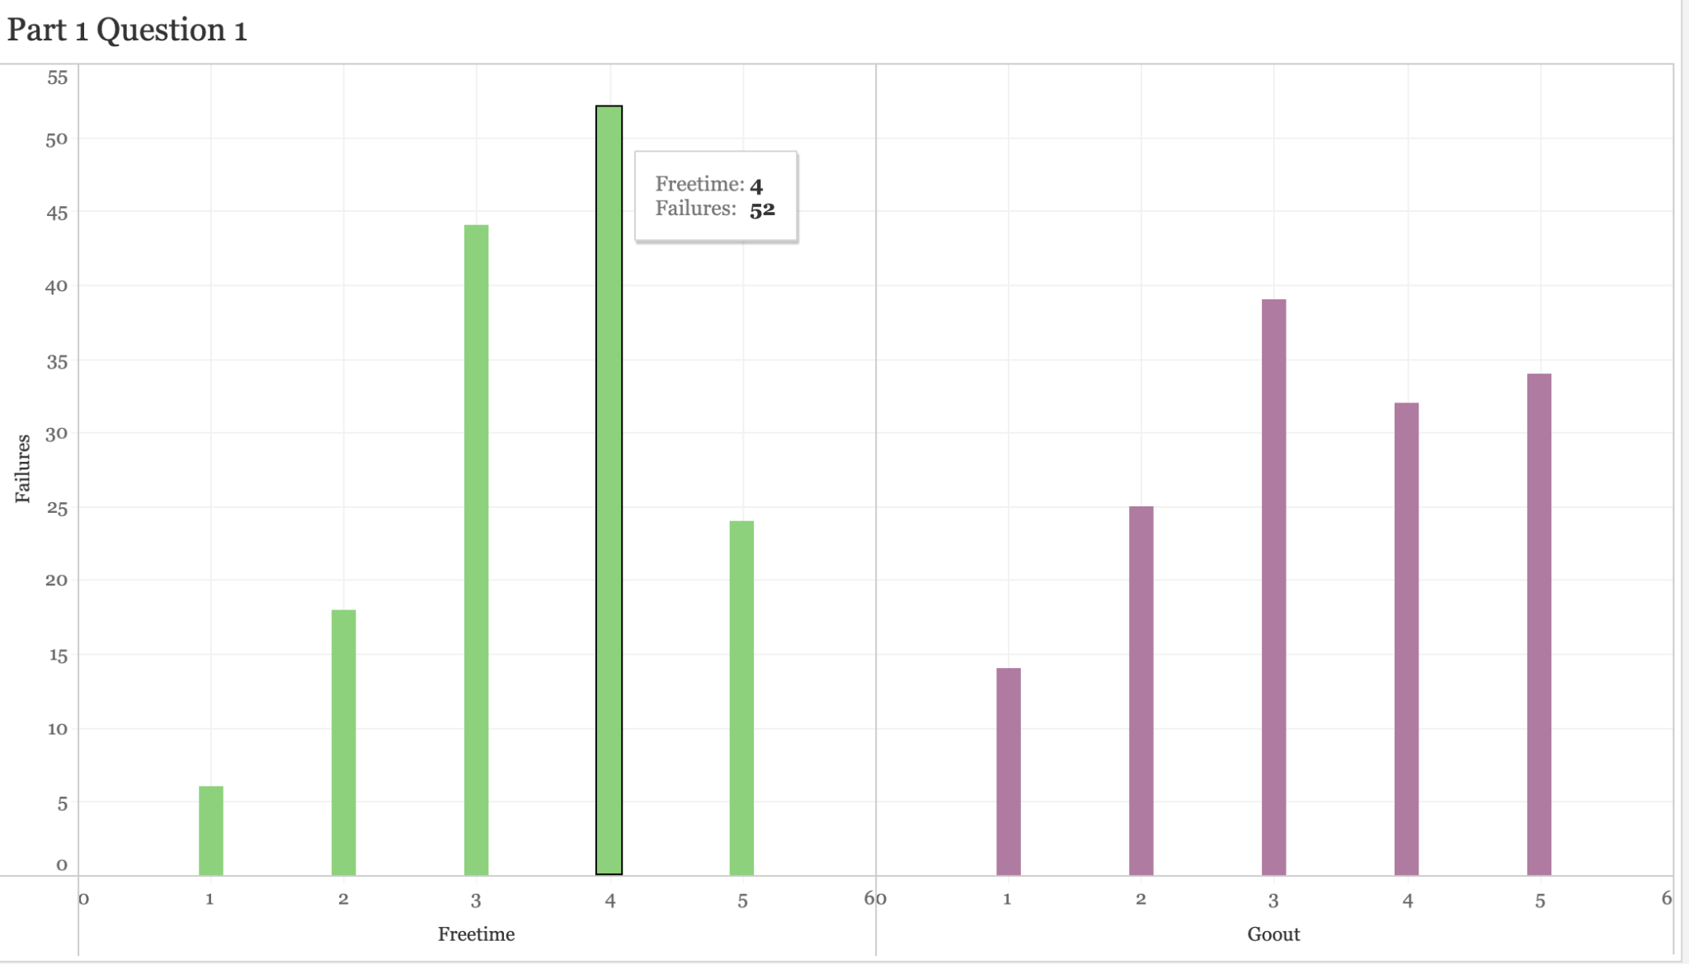

Here, we have Freetime and Goout values against Failures. The students with more free time and the ones that are more likely to go out more often, will have more chances of failing a course.

Value Range:

Goout: numeric: from 1 - very low to 5 - very high,

Failures: counts the total number of students that failed,

Freetime: 1 - very low to 5 - very high.

* **How will it affect their presence in school?**

We have visualized data based on DALC (workday alcohol consumption), WALC(weekday alcohol consumption), Address (student's home address type), School (student's school). We have filter on the school names which makes it easier for data comparison.

Value Range:

DALC: numeric: from 1 - very low to 5 - very high

WALC: numeric: from 1 - very low to 5 - very high

Address: binary: 'U' - urban or 'R' – rural

School: binary: 'GP' - Gabriel Pereira or 'MS' - Mousinho da Silveira

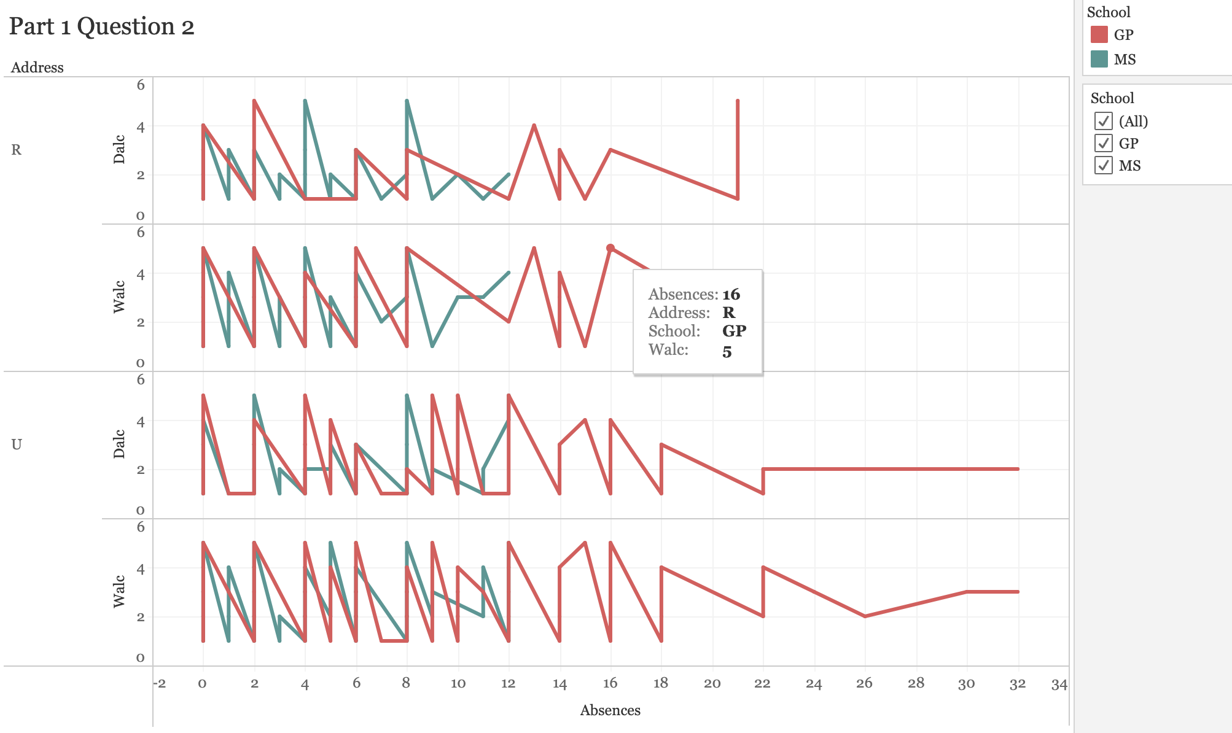

* **How can family relationships influence the student’s drinking habit?**

We are using data like family relationships and Status of parents to answer this question. We have used these data because family relations and family’s emotional condition affects a students habits majorly.

Value Range:

Pstatus: binary: 'T' - living together or 'A' - apart

Famrel: numeric: from 1 - very bad to 5 - excellent**.**

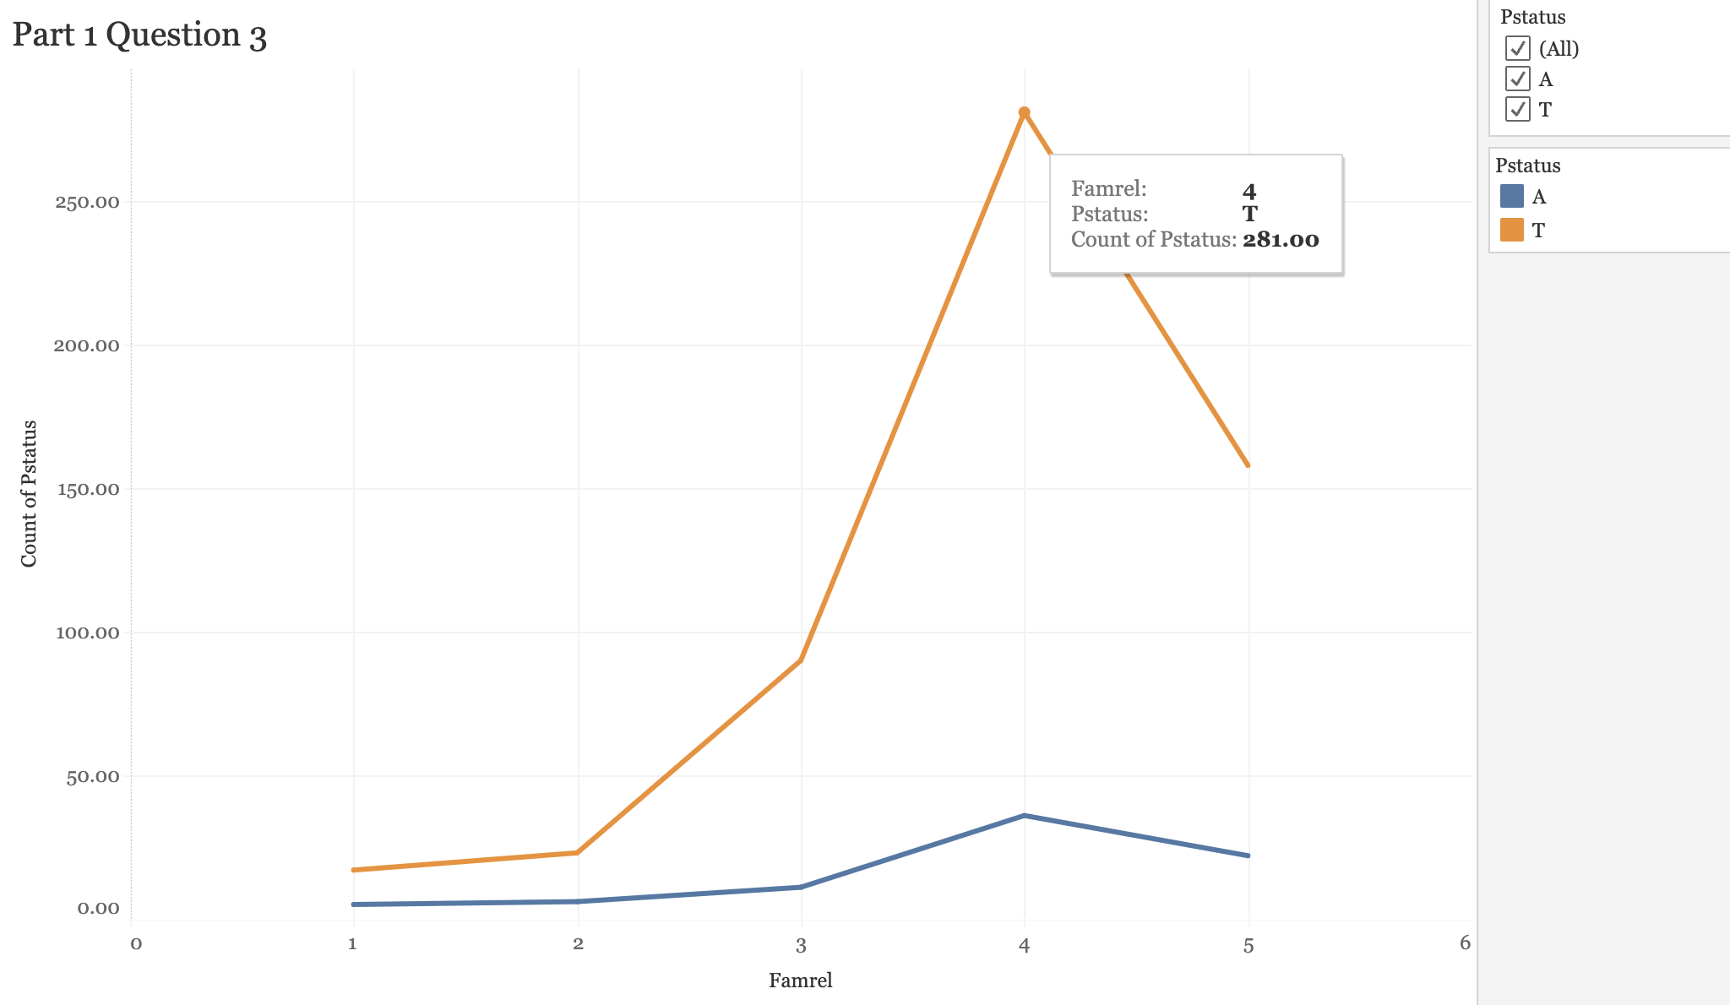

**4.2 Does alcohol affect study? / Does heavy drinking affect academic performance in college?**

* **How does it affect the student?**

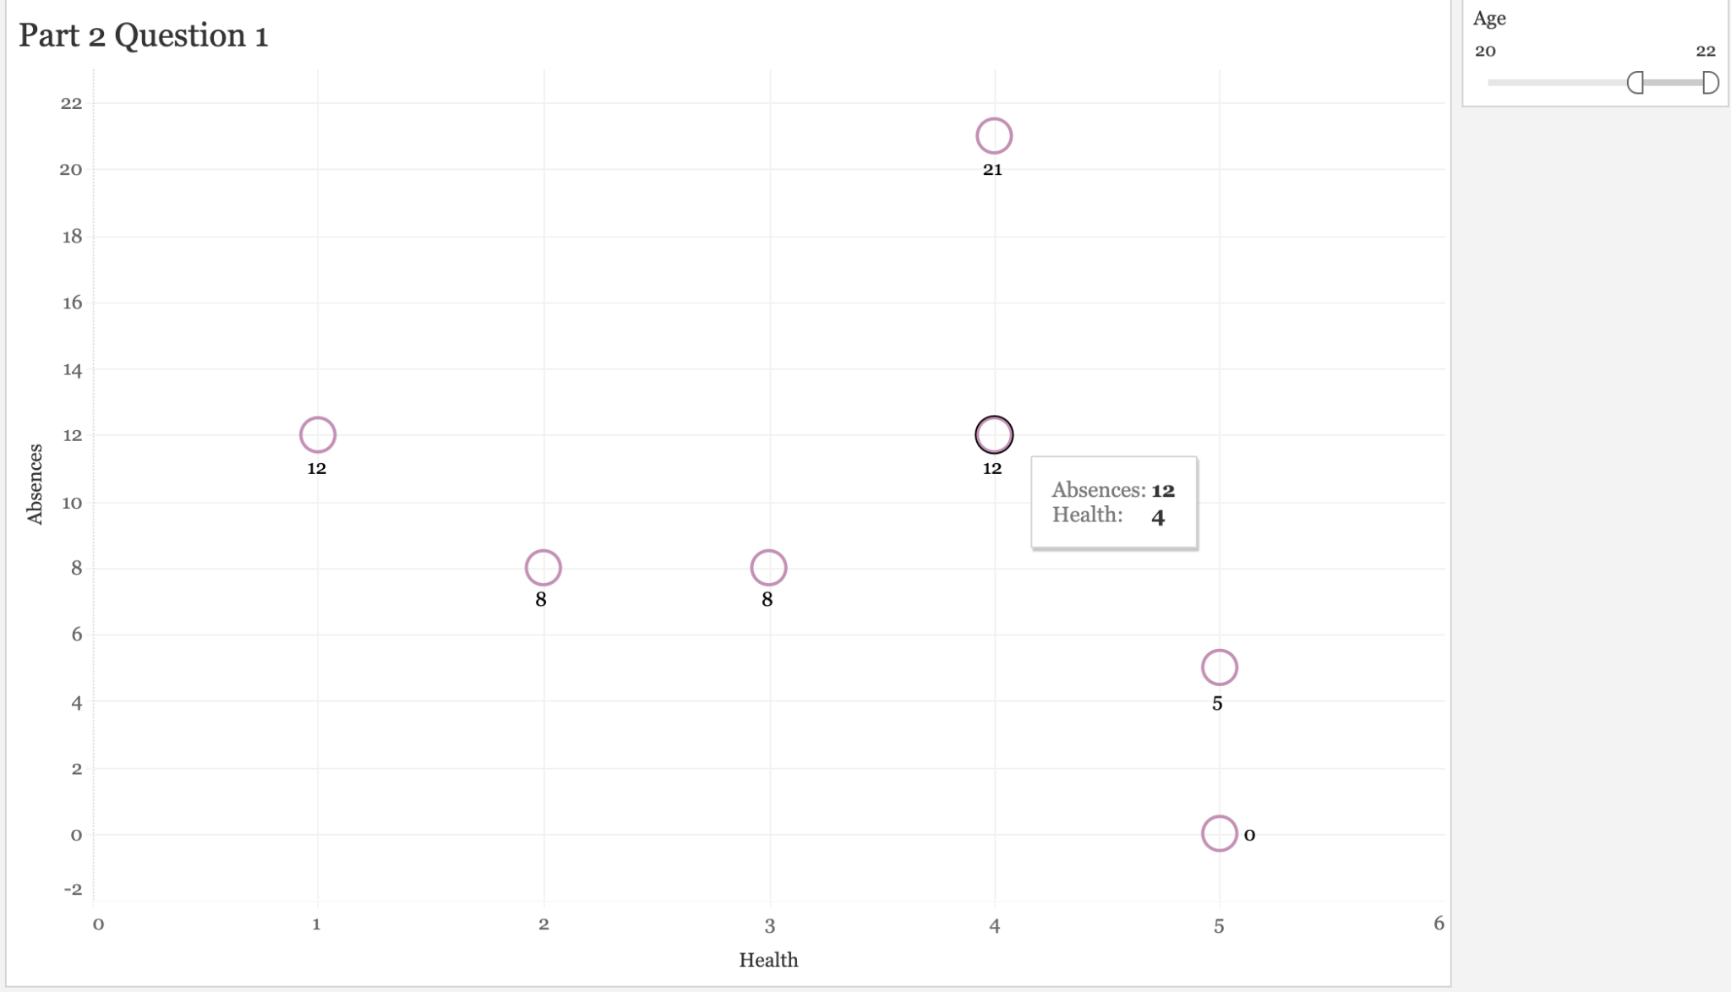

The column Absences represents the number of school absences (numeric: from 0 to 93) and the row Health represents current health status (numeric: from 1 - worst to 5 - excellent). We can observe the number of absences to their health. ​​So, the purpose of this is to reflect that if the students attend a greater number of their classes if their health does not deteriorate.

* **What will happen after a period of consumption?**

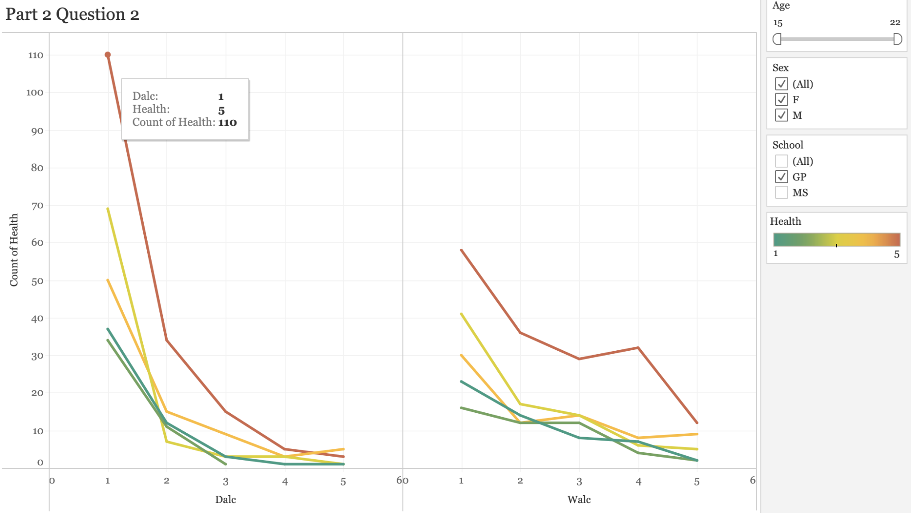

The row Dalc represents workday alcohol consumption (numeric: from 1 - very low to 5 - very high) and Walc represents weekend alcohol consumption (numeric: from 1 - very low to 5 - very high). The column Count of Health represents the number of students current health status (numeric: from 1 - worst to 5 - excellent). The purpose of this is to show that the more the students drink the more their health worsens.

* **What remedies should be done to deal with this affect?**

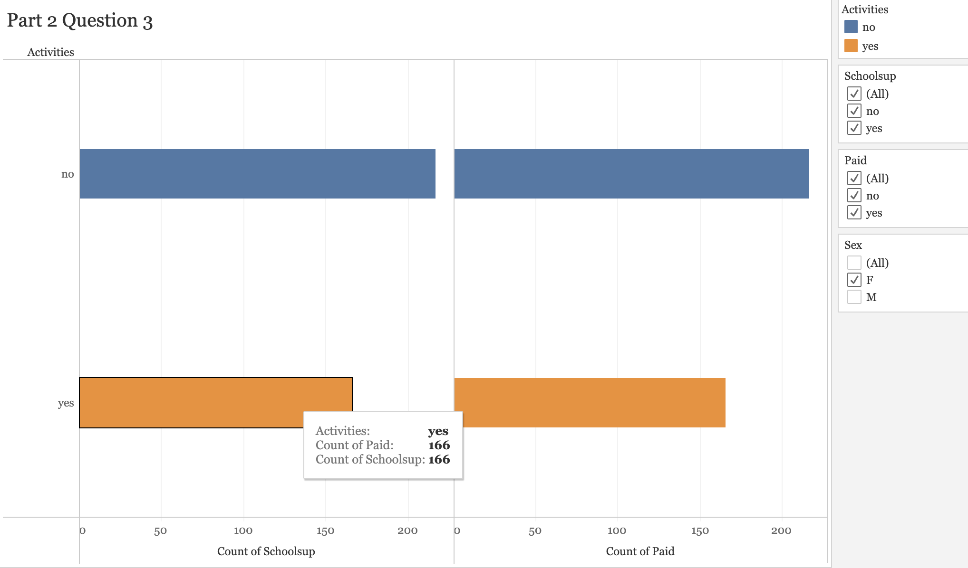

In this graph, the row Count of Schoolsup represents the extra education provided by the school (binary: ‘yes’ , ‘no’), and the columns Yes and No represents if the students have taken extra paid classes within the course subject.

**4.3 What accountability do parents and guardians have in this case**

* **Who is the student's guardian?**

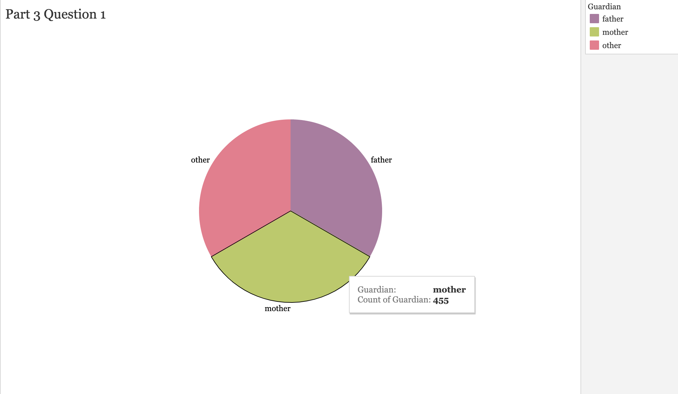

From the dataset, we categorize students’ guardian as three parts:

* Father (Purple)
* Mother (Green)
* Others (Pink)
* **How parents’ education level affect child's education?**

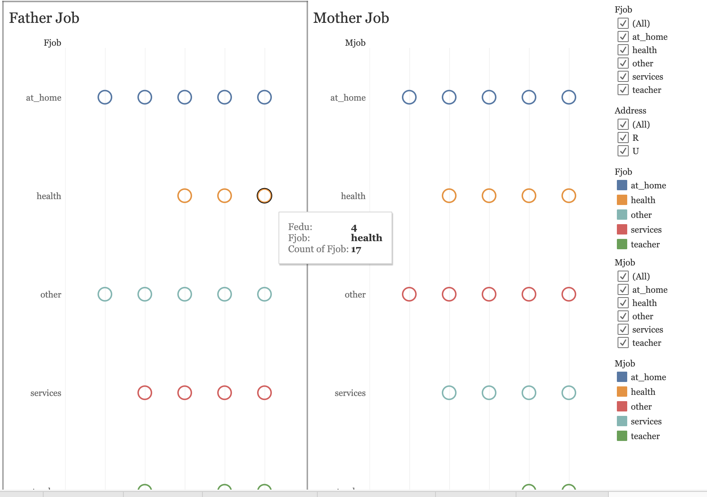

We have visualized data based on parents’ current jobs with five categories:

* Working at home (At home)
* Working in the medical field (Health)
* Working in the service industry (Services)
* Working in education (Teacher)
* Others
* **What should parents do to encourage their child to not drink alcohol at young age?**

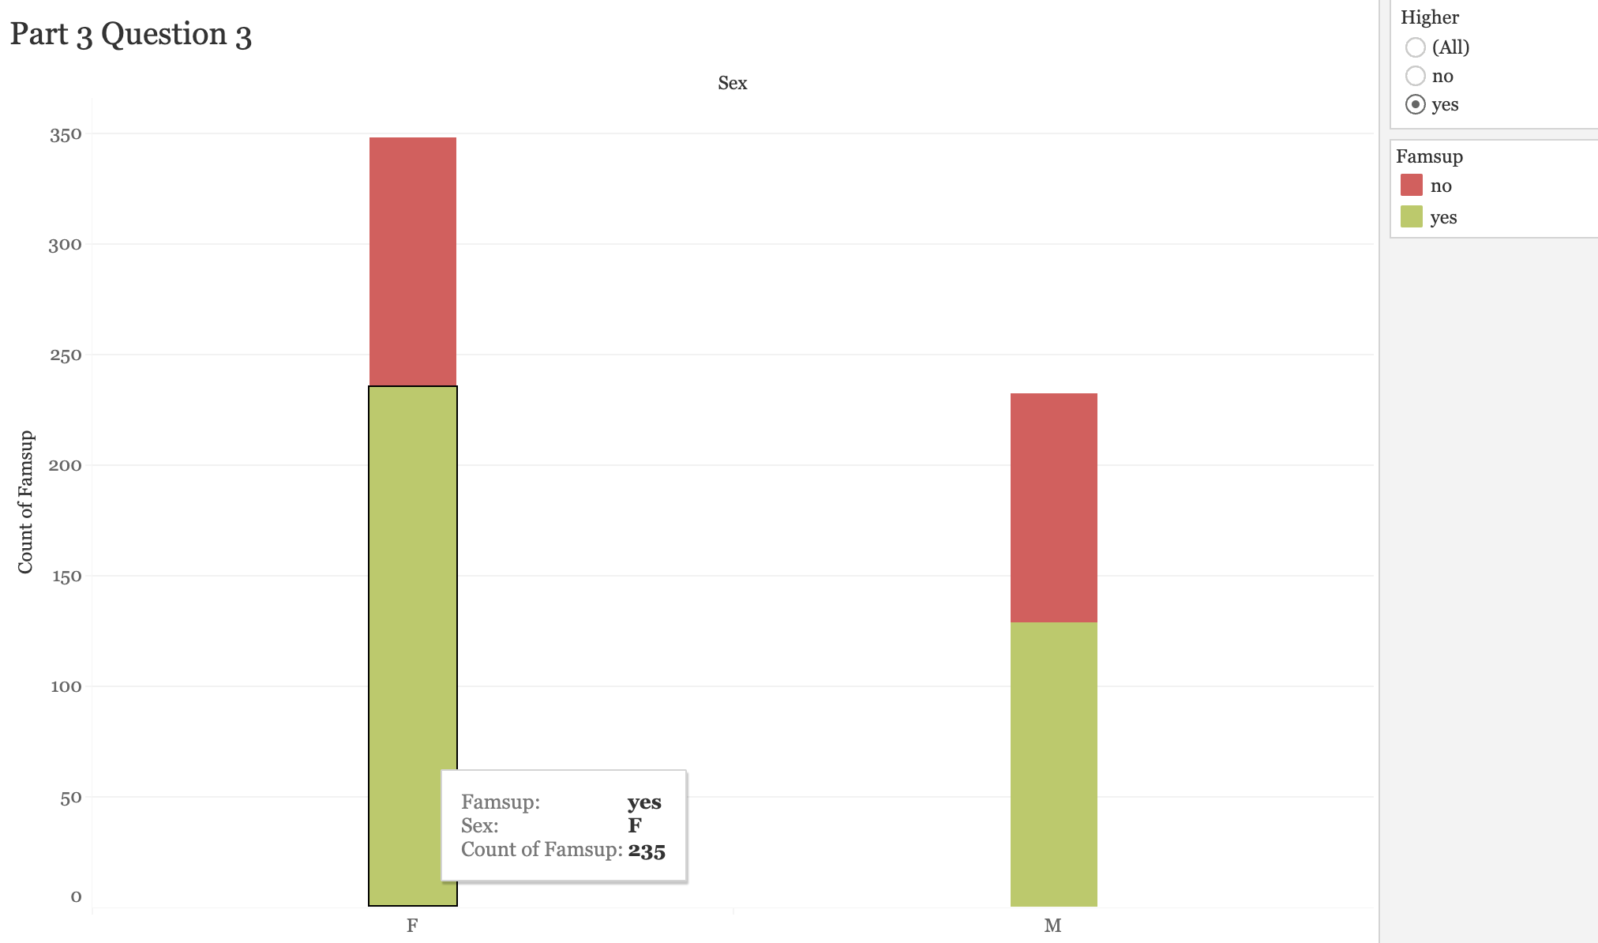

This visualization shows us family educational support (binary:yes and no). From that, they want their child to take higher education (binary: yes or no).

Student's sex (binary: 'F' - female or 'M' - male)

**5. References**

* Wikipedia Contributors (2019). *Kaggle*. [online] Wikipedia. Available at: <https://en.wikipedia.org/wiki/Kaggle>.
* Tableau (2022). *Data cleaning: The benefits and steps to creating and using clean data*. [online] Tableau Software. Available at: <https://www.tableau.com/learn/articles/what-is-data-cleaning>.
* Alex (2018). *Alcohol consumption in the United States*. [online] Vivid Maps. Available at: https://vividmaps.com/us-alcohol-consumption/.

**Images:**

* Koutsakis, G. (n.d.). *How Drinking Whisky Alters Our Memories, According To A New Study*. [online] Forbes. Available at: <https://www.forbes.com/sites/georgekoutsakis/2018/11/06/how-drinking-whisky-alters-our-memories-according-to-a-new-study/?sh=757350ae1793>.
* Newsweek. (2018). *Drinking alcohol as a teenager could have a lasting effect on the brain and metabolism*. [online] Available at: <https://www.newsweek.com/drinking-alcohol-teenager-could-affect-metabolism-study-suggest-1003643>.
* Institute, L.R. (2022). *Binge Drinking and College Students*. [online] Lighthouse Recovery Institute. Available at: <https://lighthouserecoveryinstitute.com/blog/binge-drinking-and-college-students/>.
* Hospital, M.G. (n.d.). *Large study challenges the theory that light alcohol consumption benefits heart health*. [online] medicalxpress.com. Available at: <https://medicalxpress.com/news/2022-03-large-theory-alcohol-consumption-benefits.html>.